Christy Gilliland

Daniel Abresch

Jack Amnuaysirikul

Krystina Poling

Melanie Meek

Patience Okereke

Tarig Abasit

Ziad Elharaoui

Science and Solutions

SWEN 670

Final Project Report (UMGC City Team 1)

##### VERSION HISTORY

|  |  |
| --- | --- |
| **Date** | **Description** |
| 04/23/2020 | Initial Version / Project Closeout |
|  |  |

**Contents**

1. INTRODUCTION 4

1.1 Purpose 4

1.2 Intended Audience 4

1.3 Scope 4

1.4 Reason for Project Termination 5

1.5 Definitions, Acronyms and Abbreviations 5

1.6 References 6

2. PROJECT ABSTRACT 7

2.1 Project Description 7

2.2 Project Schedule 7

2.2.1 Milestone 1 8

2.2.2 Milestone 2 8

2.2.3 Milestone 3 9

2.2.4 Milestone 4 9

2.2.5 UMGC CITY Team 1 Project Schedule 9

2.3 Project Methodology 10

2.4 Project Team 11

3 DELIVERABLES 12

3.1 REQUIREMENTS TRACKING 13

3.2 DOCUMENTS 13

3.3 CODE 14

3.4 DATABASE 14

4 CONCLUSION 14

4.1 VARIANCE REPORT 14

4.2 OVERVIEW AND INTERPRETATION OF RESULTS ATTAINED 15

4.3 RECOMMENDATIONS FOR FUTURE IMPROVEMENT 15

1. INTRODUCTION
   1. Purpose

The purpose of the UMGC City Application Final Project Report is to evaluate the processes, work quality and collect information about the project deliverables, achievements, and outcomes.

* 1. Intended Audience

The intended audience of this document includes all the members of UMGC City Team 1 and the project stakeholders. Table 1 defines the roles within the team.

*Table 1 - UMGC City Team 1 Roles*

|  |  |  |
| --- | --- | --- |
| Name | Primary Role | Secondary Role(s) |
| Israel Del Toro | Client | Stakeholder |
| Ray Gordon | Project Manager | Stakeholder |
| Dr. Mir Assadullah | Professor | Stakeholder |
| Christy Gilliland | Project Manager | Developer, DBA |
| Tarig Abasit | Developer | Requirements Analyst, DBA |
| Daniel Abresch | Developer | Tester, DBA |
| Jack Amnuaysirikul | Tester | Requirements Analyst, DBA |
| Ziad Elharaoui | Lead Developer | Requirements Analyst |
| Melanie Meek | Requirements Analyst | Tester |
| Patience Okereke | Requirements Analyst | Tester |
| Krystina Poling | Lead Developer | Tester/DBA |

* 1. Scope

The scope of this report is limited to the description of the processes by which the project was approved, and the business case for which the project was undertaken. The report details a summary of the project execution and objectives, project’s scope, timelines, recommendations for future improvements and a list of factors that affected the project results.

This report is organized into four main sections as listed below.  They constitute the overall project report for the UMGC City Application:

* Section 1. Introduction – describes and defines the overall purpose, intended audience, scope, reason for termination, references, definition, acronyms, and abbreviations of the Final Project Report.
* Section 2. Project Abstract – specifies the project description, project schedule, project methodology and project team.
* Section 3. Deliverables – comprises documents, requirements tracking, code and project resources.
* Section 4. Conclusion – Details variance report, overview and interpretation of results attained, and recommendations for future improvements.
  1. Reason for Project Termination

UMGC Team 1 successfully completed the current version of the project according to the requirements agreed upon by the stakeholders. Future improvements and requested features shall be transferred to the stakeholder for implementation by other teams.

* 1. Definitions, Acronyms and Abbreviations

Table 1 below details the definitions for the acronyms and abbreviations related to this Final Test Report of UMGC City Application.

*Table 1 - Definitions, Acronyms, and Abbreviations*

| **Acronym/**  **Abbreviation** | **Definition** |
| --- | --- |
| ChatBot | A computer program designed to simulate conversation with human users |
| CRUD | Create, Read, Update, and Delete |
| DevOps | Development Operations |
| GHz | Gigahertz |
| GUI | Graphical User Interface |
| IDE | Integrated Development Environment |
| IEEE | Institute of Electrical and Electronics Engineers |
| JDK | Java Development Kit |
| MB | Megabyte |
| OS | Operating System |
| SRS | Software Requirements Specification |
| STP | Software Test Plan |
| FPR | Final Project Report |
| UMGC | University of Maryland Global Campus |
| RTM | Requirements Traceability Matrix |
| PMP | Project Management Plan |

* 1. References

A complete list of all documents and sources referenced in this Final Project Report is detailed below.

* Mattp123. (n.d.). Web application requirements. Retrieved from <https://docs.microsoft.com/en-us/dynamics365/customerengagement/on-premises/admin/web-application-requirements>
* IEEE Standard for Software Project Management Plans. IEEE Std 1058.1-1987, 31 Aug. 1988. Accessed via <http://www.math.uaa.alaska.edu/~afkjm/cs401/IEEE830.pdf>
* Requirements Traceability Matrix – RTM. Accessed via https://project-management.com/requirements-traceability-matrix-rtm/
* SWEN 670 Capstone Project Guide. Accessed via <https://learn.umuc.edu/d2l/le/content/444089/viewContent/16973490/View>

1. PROJECT ABSTRACT

The UMGC City project is an application that was developed to improve the City of Pasadena’s existing web portals. UMGC City Team 1 focused on designing a series of interfaces to assist city officials in creating a database. Team 1 also created a user-friendly customer-facing HTML map interface to assist city residents. This capstone project allowed students to form self-organizing teams and utilize all of the previous courses taken in UMGC Graduate Software Engineering program.

* 1. Project Description

The scope of the UMGC City project is to build a free, open-source application that can be used by city officials to improve the usability of existing city web portals for their targeted audiences. The objective of the application is to enhance the user experience by helping them easily and intuitively locate applicable city ordinances for a predetermined list of frequently requested user inquiries (as determined by the city officials). In order to accomplish this goal, the application shall present the city officials with an interface to accept input of various use cases along with all the pertinent information that they think will benefit their intended audiences. The application shall process that data into appropriate tables that comprise a database. When the users visit the city web portal to search for specific ordinances, the database shall be called upon to produce appropriate output that is tailored to them in a tabular format. This generic, build-to-suit database infrastructure allows the application to be reused by any city.

* 1. Project Schedule

The following Gantt charts and project schedule represent a high-level overview of project milestones and deliverables for the UMGC City project. Team 1 successfully met each milestone due to an effective Project Manager, time management, transparent communication as a team, and following the Scrum framework. The team did experience a minor setback with the introduction of the SDD artifact, however the team was able to deliver this document on time.

* + 1. **Milestone 1**

The deliverable for milestone 1 includes the Project Plan.

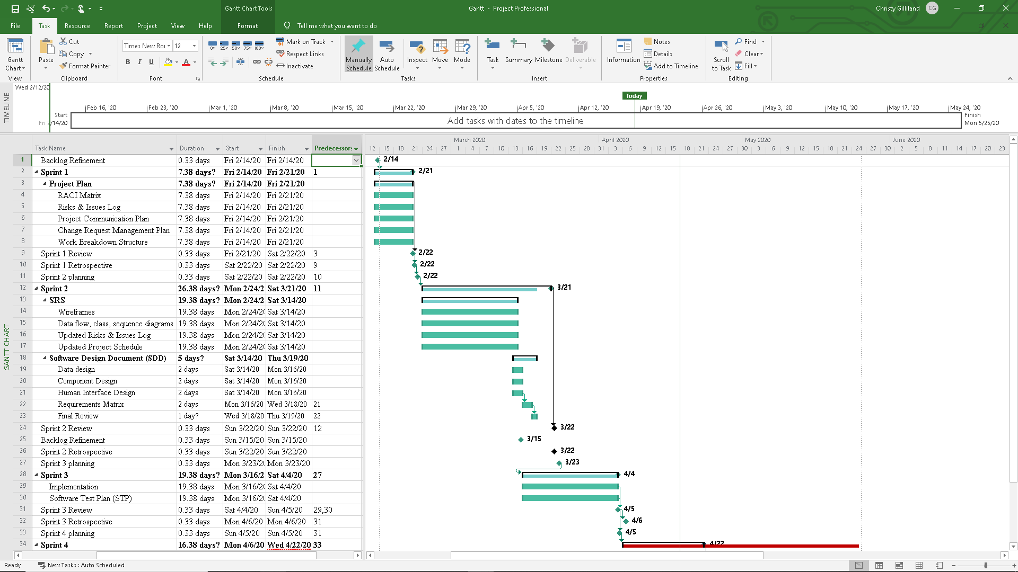

* + 1. Milestone 2

The deliverables for milestone 2 include the updated Project Plan, the Software Requirements Specification (SRS) and the Software Design Description (SDD).



* + 1. Milestone 3

The deliverables for milestone 3 include code files and the Software Test Plan (STP). It will also include all updated files from previous milestones.



* + 1. Milestone 4

The deliverables for milestone 4 include the full code and test suite, the Interface Design Document and all updated files from previous milestones.

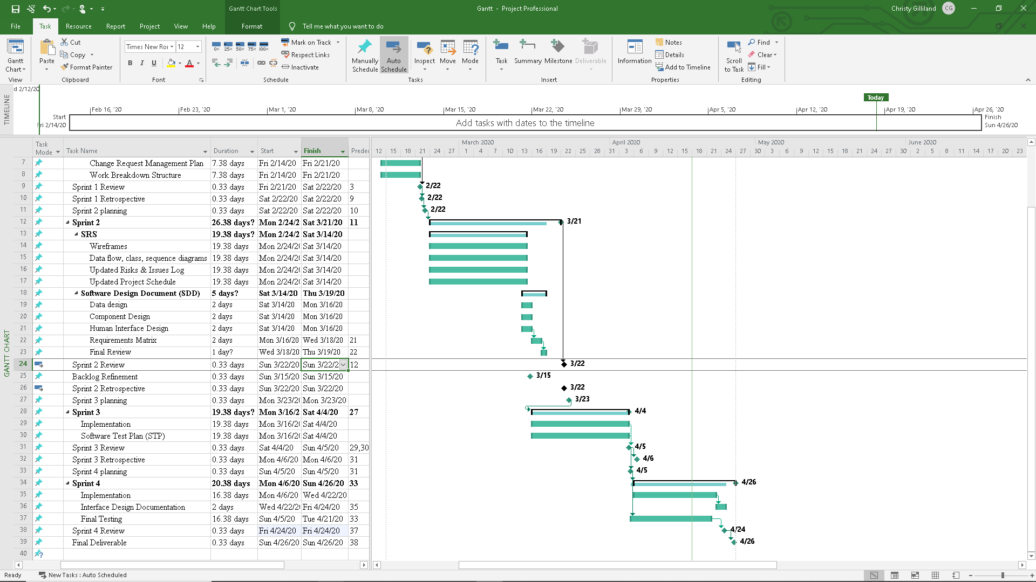

* + 1. UMGC CITY Team 1 Project Schedule

| **Date** | | **Time** | **Meeting** | **Attendees** |
| --- | --- | --- | --- | --- |
| 2/14 | 9 PM EST | | Backlog Refinement | Required: Christy Gilliland, Roy Gordon |
| Optional: Team members |
| 2/22 | 12 PM EST | | Sprint 1 Review | Required: Christy Gilliland, Team members |
| Optional: Roy Gordon |
| 2/23 | 12 PM EST | | Sprint 1 Retrospective and Sprint 2 Planning | Required: Christy Gilliland, Team members |
| Optional: Roy Gordon |
| 3/15 | 12 PM EST | | Sprint 2 Review and Backlog Refinement | Required: Christy Gilliland, Roy Gordon |
| Required: Team members |
| 3/16 | 9 PM EST | | Sprint 2 Retrospective and Sprint 3 Planning | Required: Christy Gilliland, Team members |
| Optional: Roy Gordon |
| 4/05 | 12 PM EST | | Sprint 3 Review | Required: Christy Gilliland, Roy Gordon |
| Required: Team members |
| 4/06 | 9 PM EST | | Sprint 3 Retrospective and Sprint 4 Planning | Required: Christy Gilliland, Team members |
| Optional: Roy Gordon |
| 4/23 | 9 PM EST | | Sprint 4 Review | Required: Christy Gilliland, Roy Gordon |
| Required: Team members |

* 1. Project Methodology

Team 1 implemented Scrum methodology and approached development in time boxed efforts referred to as sprints. Each sprint was limited to a specific time frame, which is typically lasting anywhere between two to three weeks. At the end of a sprint, the team finished a portion of the overall deliverable. During each sprint, designated sets of requirements called stories were selected from the product backlog and were built in to the product. The team selected this particular framework due to the possibility of changing requirements. Scrum allowed the team to quickly analyze work and shift to meet new requirements.

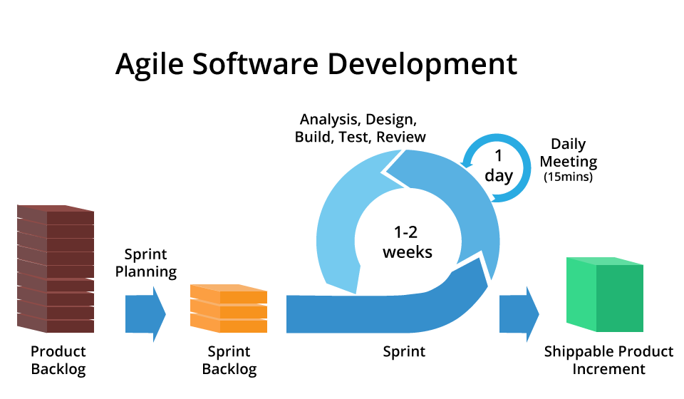

Figure 1 – Agile Process (image from www.codingmart.com)

Scrum is a development model that is comprised of a series of meetings that help guide the team towards a completed product. Team 1 actively participated in all Scrum ceremonies, including daily scrum, backlog grooming, scrum of scrums, sprint planning meeting, sprint review and sprint retrospective.

* 1. Project Team

Members of the team are defined as follows:

● Project Manager/Scrum Master: Christy Gilliland

● Developers: Daniel Abresch, Krystina Poling, Tarig Abasit, Ziad Elharaoui,

● Testers: Jack Amnuaysirikul, Melanie Meek, Patience Okereke

● Requirements Analysts: Melanie Meek, Patience Okereke

● DevOps Team: Johnny Lockhart, Anteneh Haile

● Stakeholders: Israel Del Toro, Mir Assadullah, Roy Gordon

● Customer: Israel Del Toro

● Product Owner: Roy Gordon

1. DELIVERABLES

As specified in the UMGC City Team 1 Project Plan at the beginning of the class, the updated project deliverables for the map/web-based interface of UMGC City Application are shown in the Table 1 below:

Table 1 - Project Deliverables

|  |  |  |  |
| --- | --- | --- | --- |
| # | Name | Description | Due Date |
| 1 | Project Plan | A comprehensive baseline document that established what needs to be achieved in the project, how it should be carried out, who are involved, and how the success or failure shall be reported at the end. This serves as a reference tool to clearly communicate essential project information to all the stakeholders. | Milestone 1  February 23, 2020 |
| 2 | Updated Project Plan  Software Requirements Specification (SRS)  Software Design Document (SDD) | Incorporated with feedback. See previous description above.  A descriptive document that outlines a software system to be developed. It involves rigorous and thorough assessment of requirements that the software is expected to deliver. The SRS shall explain what the software does (functional and non-functional requirements) and how it is supposed to perform per system specifications.  An essential document that provides the top-level architecture and design approach for the software to be built. The goal is to thoroughly describe how the software system should be designed and implemented with all the necessary sub-components. | Milestone 2  March 21, 2020 |
| 3 | Updated Project Plan  Updated SRS  Updated SDD  Software Test Plan (STP) | Incorporated with feedback. See previous description above.  Incorporated with feedback. See previous description above.  Incorporated with feedback. See previous description above.  A critical document that provides the overall approach, scope, and strategy of all testing activities to ensure that the software requirements as specified in the SRS are implemented and met satisfactorily. | Milestone 3  April 5, 2020 |
| 4 | Final Project Report  Software Test Report | An important document created at the end of the project to show what the team delivers and how well the project performs according to the specifications. It includes important concluding remarks and recommendations for future work.  A detailed document that records various testing activities as specified in the STP. The test results are objectively evaluated and carefully recorded to identify the pass/fail status of the software requirements. | Milestone 4  April 26, 2020 |

* 1. REQUIREMENTS TRACKING

In order to objectively measure the success or failure of the UMGC City Application, software requirements (as specified in the SRS) are tracked to ensure that the map/web-based module from UMGC City Team 1 is tested and delivered as promised. This traceability of test cases to all software requirements is done via the Requirements Traceability Matrix (RTM) for easy monitoring of requirements status. Accurate tracking of requirements is critically important in the project because it shows the current software development progress. Future effort from new project teams can be carried on easily with robust requirements tracking. The RTM is presented in the Software Test Plan document.

* 1. DOCUMENTS

This subsection gives a list of all project documents (textual) that shall be delivered at the end of the 2020 Spring UMGC SWEN 670 Software Engineering Project course:

* Updated Project Plan
* Updated Software Requirements Specification
* Updated Software Design Document
* User Interface Document (Tutorial)
* Updated Software Test Plan
* Final Project Report
* Software Test Report

Final documents can also be found at <https://1drv.ms/u/s!Aq84NT9YxlnRal86aAMAevw3BRo?e=GW6QVr> .

* 1. CODE

All code files associated with the backend of the application are in the repo found at <https://github.com/umgc/umgc.city.backend.web>.

All code files associated with the frontend of the application are in the repo found at <https://github.com/umgc/umgc.city.frontend>.

* 1. DATABASE

The information for the working database for the city of Pasadena is listed below:

|  |  |
| --- | --- |
| HOST | ec2-3-234-169-147.compute-1.amazonaws.com |
| DATABASE | da4hsq7n5o73ko |
| USER | tqhbdpgaxrvxsx |
| PORT | 5432 |
| PASSWORD | 83f4c6d22bf009a1a3c8a208ba728a9630347c5f71ff8593be4511f72b2b3a09 |
| URI | postgres://tqhbdpgaxrvxsx:  83f4c6d22bf009a1a3c8a208ba728a9630347c5f71ff8593be4511f72b2b3a09@ec2-3-234-169-147.compute-1.amazonaws.com:5432/da4hsq7n5o73ko |

1. CONCLUSION

## This section details the variance report, overview, and interpretation of results for UMGC City Application Version 1.0. It also explains additional requirements proposed by the stakeholder outside the initial requirements binding the contract.

* 1. VARIANCE REPORT

No significant changes to the project scope or schedule have occurred since the initial Project Plan was released.

* 1. OVERVIEW AND INTERPRETATION OF RESULTS ATTAINED

Team 1 has successfully implemented the UMGC City Web Application according to the requirements set forth by the stakeholders during the requirements analysis phase. A strong emphasis had been placed on a more “user-friendly” interface for both city administration users and city resident users. The implementation of this web application uses many “best practice” design principles for creating user interfaces. The entire application operates on freeware and cloud-hosted resources to make it easier to deploy to many different cities.

* 1. RECOMMENDATIONS FOR FUTURE IMPROVEMENT

Below are the recommended requirements listed by project stakeholders for future improvement.

* Changing the email to send an email link to reset user password instead of sending the actual password.
* Expanding the data model to allow a city to have more than just one user so that several people from their office can access the data.
* The map interface created for this pilot project was done manually and created specifically for the City of Pasadena. This is not a feature expected to be bundled in future implementations, however, a map creation tool may serve as a critical selling point for this application.
* Security functionality should be implemented in the admin portal.
* Implementation of the Quick Reference Page creation feature.
* Implementation of the File Upload (csv) feature.